Department of Defense (DoD)

**Design Framework for TRADOC Enterprise Calendar(TEC)**

**VERSION 1.0**

**FOR**

**DEPUTY CHIEF of STAFF, G-6 (DCS G-6)**

**TRADOC KNOWLEDGE ENVIRONMENT (TKE)**



DISTRIBUTION IS LIMITED TO U.S. GOVERNMENT AGENCIES AND THEIR CONTRACTORS.

This page intentionally blank

change log

This record shall be maintained throughout the life of the document. Each published update shall be recorded. Revisions are a complete re-issue of entire document. A revision shall be made whenever the cumulative changes reaches ten percent (10%) of this document’s content.

|  |  |  |  |
| --- | --- | --- | --- |
| **CHANGE / REVISION RECORD** | | | |
| **Date** | **Page/Paragraph** | **Description of Change** | **Made By:** |
| <Date> | Initial Document | Initial Document Creation | <last, first> |
|  |  |  |  |
|  |  |  |  |
|  |  |  |  |
|  |  |  |  |
|  |  |  |  |
|  |  |  |  |
|  |  |  |  |
|  |  |  |  |
|  |  |  |  |
|  |  |  |  |
|  |  |  |  |
|  |  |  |  |

tABLE OF CONTENTS

SOLUTION WALK THROUGH 2

USE CASE 1: 2

USE CASE 2: 2

USE CASE 3: 2

Structure OVerview 2

SharePoint Structure: 2

Code Structure: 2

Solution Permissions 2

Solution COLUMNS 3

Solution CONTENT Types 3

Solution List(s) 4

<List Name> 4

Description: 4

Versioning Settings: 4

Advanced Settings: 4

List Permissions: 4

Associated Workflows: 5

WORKFLOWs 5

<Workflow Name> 5

Description: 5

Workflow Type: 5

Associated SharePoint Object: <list name or content type> 5

Start Options: 5

Syntax Screen Shots: 5

Custom Code 5

Client Side Code 5

File Name: 5

Summary: 5

Programming Language: 5

Syntax: 5

Server Side Code 5

File Name: 5

Summary: 5

Programming Language: 6

Syntax: 6

Code Deployment Instructions: 6

UML Diagram 6

APPENDIX 7

Customer Permissions 7

Data Dictionary 7

executive summary

The following SharePoint solution was designed for <customer name>. …

# SOLUTION WALK THROUGH

The following are use cases are common for the <name> SharePoint solution

## USE CASE 1:

## USE CASE 2:

## USE CASE 3:

# Structure OVerview

The following SharePoint site structure and code structure (if need be) have been implemented for this solution. The TEC site collection comprise of comprise of one top level site and 47 subsites. Within each of the sites are there associated lists and document libraries.

## Site Collection Hierarchy:

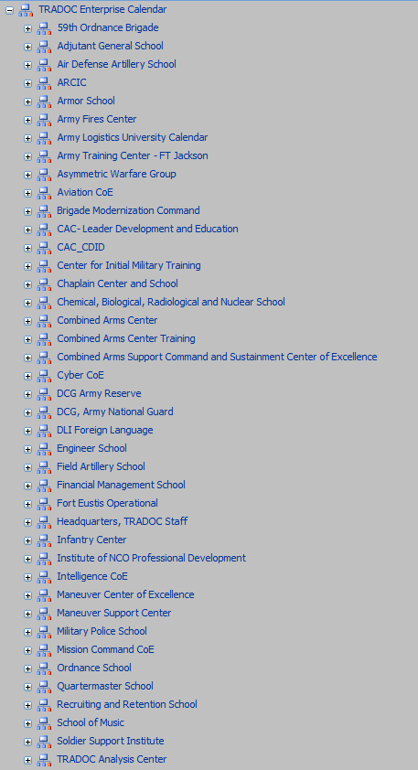

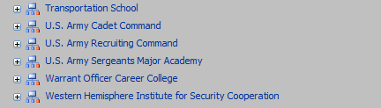

## List and Libraries:

The lists and document libraries for each site within the site collection have similar hierarchies. The major variation is the fact that each site have a calendar for which the display name references to the site itself with slight naming differences. For example, the ARCIC subsite have two calendars. One calendar name is ‘Calendar’ and the other calendar name is ‘ARCIC Calendar.’

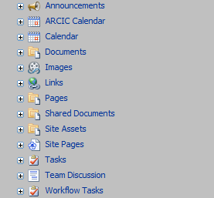

## Code Structure:

# Solution Permissions

|  |  |  |
| --- | --- | --- |
| **Group Name** | **Group Type** | **Permission Level(s)** |
| Owners | SharePoint Group | Full Control |
|  |  |  |
|  |  |  |
|  |  |  |
|  |  |  |

# Solution COLUMNS

|  |  |  |  |  |
| --- | --- | --- | --- | --- |
| **Column Name** | **Column Group** | **Description** | **Values/Choices** | **Default Value** |
|  |  |  |  |  |
|  |  |  |  |  |
|  |  |  |  |  |
|  |  |  |  |  |
|  |  |  |  |  |

# Solution CONTENT Types

|  |  |  |  |
| --- | --- | --- | --- |
| **Content Type Name** | **Description** | **Parent Content Type** | **Group** |
| Owners | SharePoint Group | Full Control |  |
|  |  |  |  |
|  |  |  |  |
|  |  |  |  |
|  |  |  |  |

# Solution List(s)

## <List Name>

### Description:

### Versioning Settings:

### Advanced Settings:

### List Permissions:

|  |  |  |
| --- | --- | --- |
| **Name** | **Type** | **Permission Levels** |
| Owners | SharePoint Group | Full Control |
|  |  |  |
|  |  |  |
|  |  |  |
|  |  |  |

### Associated Workflows:

# WORKFLOWs

## <Workflow Name>

### Description:

### Workflow Type:

### Associated SharePoint Object: <list name or content type>

### Start Options:

### Syntax Screen Shots:

# Custom Code

## Client Side Code

### File Name:

### Summary:

### Programming Language:

### Syntax:

## Server Side Code

### File Name:

### Summary:

### Programming Language:

### Syntax:

### Code Deployment Instructions:

### UML Diagram

# APPENDIX

## Customer Permissions

## Data Dictionary